HILLCROFT COLLEGE. A TUNNEL TO SURBITON STATION?

David A. Kennedy, PhD

29 June 2026

ABSTRACT
Hillcroft College, Surbiton KT6 6DF was built in 1877 as a mansion for Wilberforce Bryant, Chairman of Bryant & May, safety match manufacturers. There is a local tradition that there was a tunnel from the mansion to Surbiton Station. Later, Bryant built a theatre lower down on his grounds, and closer to the station, for the benefit of the local community. Known as The Gables, this was in use in 1885. It was established that there was a tunnel between the mansion and The Gables but there was no evidence that this extended as far as Surbiton Station. It is conjectured that this was the basis of the local tradition.
INTRODUCTION
Hillcroft College [Figure 1] formerly a campus of The Richmond and Hillcroft Adult Community College, is located on South Bank, Surbiton KT6 6DF. It occupies a mansion, built in 1877 and set in its own grounds, that was built for Wilberforce Bryant, the Chairman of Bryant & May, manufacturers of safety matches. Recently, the Kingston upon Thames Society was asked to comment on a report that once there was a tunnel from the mansion leading to Surbiton Station. The enquiry was passed to me, and I recalled a tradition about the tunnel. Thereafter, some research was undertaken.
Figure 1. Rear of Hillcroft College, looking towards Surbiton Station. Computer-enhanced image created in June 2026 by David A. Kennedy.
HISTORIES OF HILLCROFT COLLEGE
In 1964, Margaret Joyce Powell, published privately The History of Hillcroft College. The First Forty Years, 1920-1960. June Sampson wrote, Majesty of a Mansion Made of Matches which was published in the Surrey Comet newspaper on 3 July 1976. An article by Doreen Erhlich, A Mansion Made from Matches: Hillcroft College, Surbiton, was published in Surrey History in 1991 [Vol. IV, No.4, pp. 231-244]. From these and other sources the following account is offered.
The Building News of 18 May 1877 outlined the mansion, designed by Rowland Plumbe, FRIBA. Later, Bryant commissioned a private theatre within the grounds. It is not mentioned in The Building News article, but it can be dated to 1885 by a report in the Surrey Comet of 6 June that the Bryants’ new hall at the bottom of their beautiful grounds at South Bank was inaugurated with a meeting of the Sunday school teachers of Christ Church, Surbiton. Moreover, that the new venue then was called “The Gables” was established by the Surrey Comet of 12 December 1885 which announced a grand evening concert to be held in aid of funds for Thames Ditton Cottage Hospital.
In 1888, Bryant sold the property to Alfred Cooper, chairman of the Ridgways Tea Company. For about a year during the Boer War, he allowed The Gables to be used as a private convalescent military hospital. He funded this and it earned him a knighthood. Sir Alfred Cooper, in 1906, sold the property to Herbert Boret, a shipbroker. Bryant, Cooper and Boret permitted The Gables theatre to be used, free of charge, for the benefit of the local community, e.g., meetings, amateur theatrical performances and musical events [Figure 2].
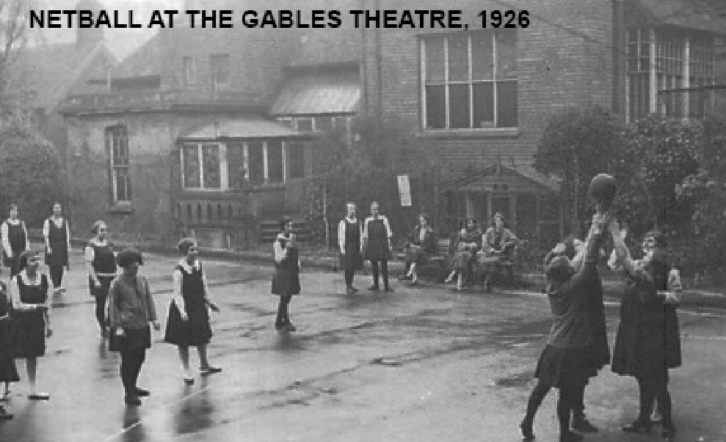
Figure 2. The Gables Theatre, looking towards Hillcroft College.
Computer-enhanced image, from Ehlich, 1991.
In 1926, Boret sold the property to The Working Women’s College, and it became Hillcroft College. According to Erhlich, after Cooper’s departure, R. C. Sherriff developed his stagecraft at the Gables when he wrote and presented plays for the Kingston Adventurers’ Dramatic Society and in 1927 a professional repertory company used the theatre. By then, the establishment was known as “The Hillcroft Theatre”.

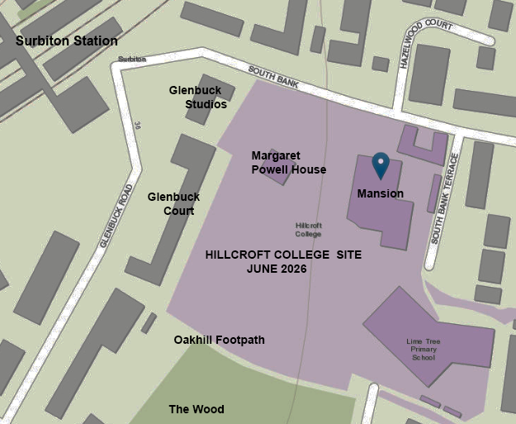
Figure 3. Plan, created in June 2026 by David A. Kennedy, showing the Hillcroft College area in June 2026. Margaret Powell House stands roughly on the site of the Hillcroft Theatre.

Various reports in the Surrey Advertiser refer to the Hillcroft Theatre. On 25 November 1933 it was said that The Hinchley Wood Amateur Dramatic Society had staged there, “The Creaking Chair”. On 9 June 1934, it reported that “Hawk Island” a murder mystery, had been performed in aid of the new Surbiton Hospital building fund. On 26 January 1935, it reported that the Hillcroft Theatre had been delightfully renovated and a cocktail bar installed. On 9 February, an advertisement for The Hillcroft Theatre Club, Surbiton, appeared. “Granite” with “a brilliant West End cast” would be staged in the coming week, there was a free car park, and the theatre was open on Sundays. On 2 March 1935, the Club offered “weekly plays of unusual interest” and Monday night there were dances from 8 pm to 12 midnight. Prices for stalls and a box were given and yearly membership was five shillings.
Erhlich wrote that in, in 1934, the College, in financial difficulty and finding the theatre to be more of a liability than an asset, sold it so that flats could be built on the site. However, it was clear that the theatre was still in business by 2 March 1935. Hillcroft Theatre Club, in Glenbuck Road, was still listed in the 1935 edition of Kelly’s Directory of Kingston, Surbiton & District, Moreover, it was not until 1938 that the blocks of flats, Glenbuck Studios and Glenbuck Court [Figure 3], had occupants listed in the Kingston Electoral Register.
A TUNNEL TO SURBITON STATION?
Doreen Ehrlich, 1991, wrote that a tunnel ran from Wilberforce Bryant’s mansion to a private theatre in its grounds and “… there are still the workings of the tunnel that led from the main house to the theatre box.” Furthermore, it would be appropriate for such a construction to safeguard the residents from inclement weather when they made their way to and from the theatre.
At a recent visit to Hillcroft College, it was possible to see “the workings of the tunnel” alongside a pathway that led down the slope towards Margaret Powell House and, closer to the College, what were believed to be ventilation shafts [Figures 4 & 5].
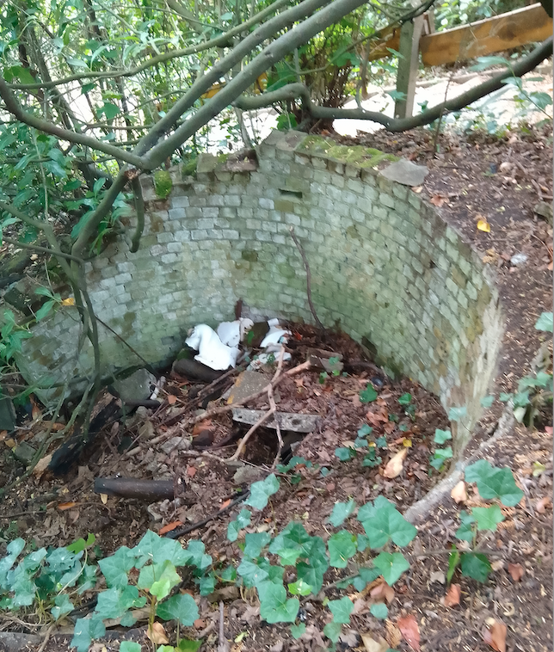
Figure 4. “the workings of the tunnel that led from the main house to the theatre box”? Photograph by David A. Kennedy, 7 June 2026.
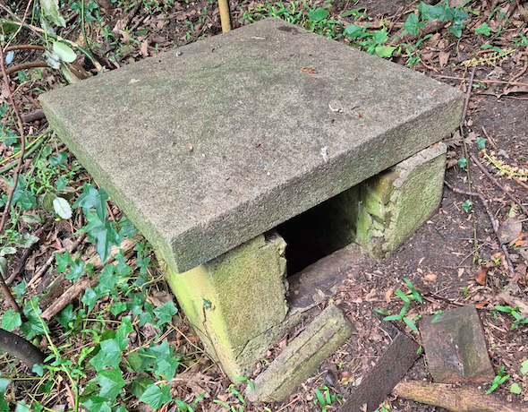
Figure 5. A ventilation shaft for the tunnel?
Photograph by Jon Pitman, June 2026

With reference to the available evidence how would Wilberforce Bryant’s tunnel have been constructed?
POSSIBLE CONSTRUCTION OF THE TUNNEL
The article in The Building News, cited above, noted that there were cellars under the back staircase wings and it talked of the “special peculiarities of the site”. One of these was the fact that the ground sloped towards the railway. Today, Hillcroft College stands at an elevation of about 30 m above sea level, while Surbiton Station’s elevation is 20 m. Constructing a tunnel between a building on the top of a slope and one at the bottom of a slope might have presented a problem. How would it have been solved?
At a relatively short distance from the main house, and lower down from it, there was a semicircular brick retaining wall and the area within it had been used as a rubbish dump. One of the dumped items appeared to be a broken piece of concrete slab. Furthermore, it was known that badger diggings had exposed what appeared to be metal bars.
These items suggested that a “cut and cover” tunnel had been constructed. This can be reduced to a hypothesis that from the “cellars under the back staircase wings” of the main house, a short tunnel, with ventilation shafts, was dug to the point where the retaining wall stands today. From there a trench was dug to meet up with a short tunnel leading from cellars under the Gables. This trench was converted into a tunnel by laying metal bars across the top, laying concrete above it to create a roof, and then restoring the ground above it to its original condition. Figure 6 shows the possible line of the tunnel from Wilberforce Bryant’s mansion, which became Hillcroft College, to his private theatre, that became Hillcroft Theatre.

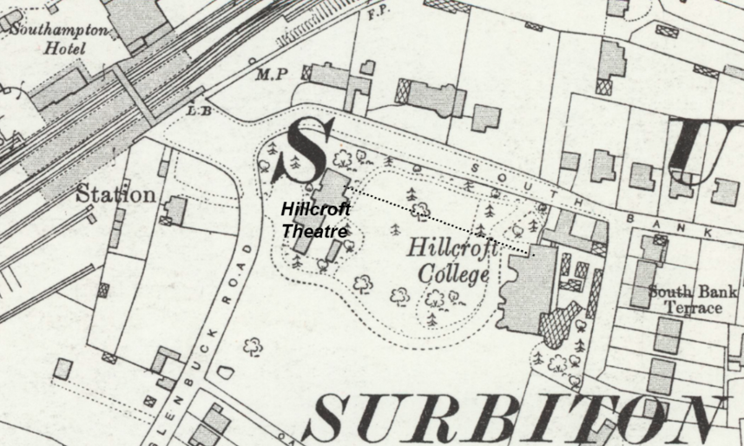
Figure 6. Edited section of a 25 inch OS map, 1932, showing Hillcroft College and Hillcroft Theatre. The dotted line marks the possible line of the tunnel.

DISCUSSION & CONCLUSIONS
Evidence was found that a tunnel from Bryant’s mansion to The Gables was constructed by 1885. Exactly when the tunnel ceased to be used was not discovered. However, what had become Hillcroft Theatre, had been demolished by 1938. There was no evidence that the tunnel ever extended directly to Surbiton Station. But, it seems reasonable that at the time of The Hillcroft Theatre Club there was an entrance on the Surbiton Station side which enabled members to gain access via the car park. It can be conjectured that Wilberforce Bryant and later owners would have been able to walk from the mansion to the theatre and, from there, walk the relatively short distance to Surbiton Station with minimal exposure to the weather. Local residents would have visited the theatre and heard about the tunnel. Accordingly, the knowledge spread by word of mouth. It is concluded that this is the basis of the tradition that Wilberforce Bryant could access Surbiton Station via a tunnel.
ACKNOWLEDGEMENTS
I am most grateful to Alison Fure, Jon Pitman, John McCarthy and staff of the Kingston History Centre for their help in this research.

There is a copy in the reference section of Surbiton Library, Cat. No. R.942.194.
I am grateful to Jon Pitman for pointing this out.
I am grateful to Alison Fure for this information.
https://en.wikipedia.org/wiki/Tunnel_construction

